KOSSi EGLA

Lab 12

**Introduction**

In this lab, are going to heavily work with thyristors to develop methods measuring key parameters of thyristors, and to investigate some basic applications of these device. We are also going to use the thyristor to build a dimer and alrm.

**Part One**: Extract 𝑽𝒈𝒕 and 𝑰𝒈t

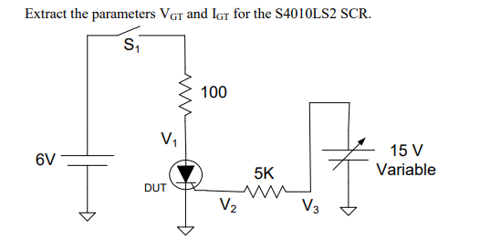

With V3 set to 0V, close the switch S1. The SCR should be in the “OFF” state right after S1 is closed. Monitor the voltage V1 on an oscilloscope. The voltage V1 should be 6V when the SCR is in the “OFF” state.

=

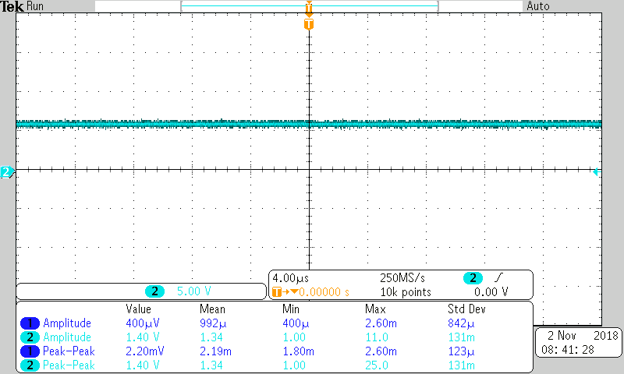

Gradually increase V3 until the voltage on V1 drops. The drop in V1 will occur when the SCR is triggered and the drop in the voltage V1 should be both abrupt and rapid. When that happens, don’t change V3 anymore

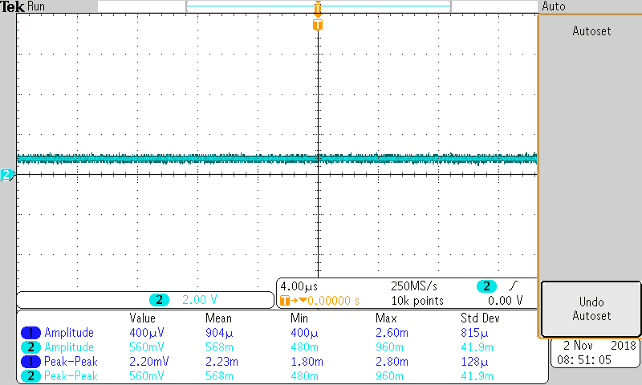

Measure V2 with another port on the oscilloscope, V2 will equal VGT. Measure V3 with the same instrument. The trigger current IGT is given by the expression

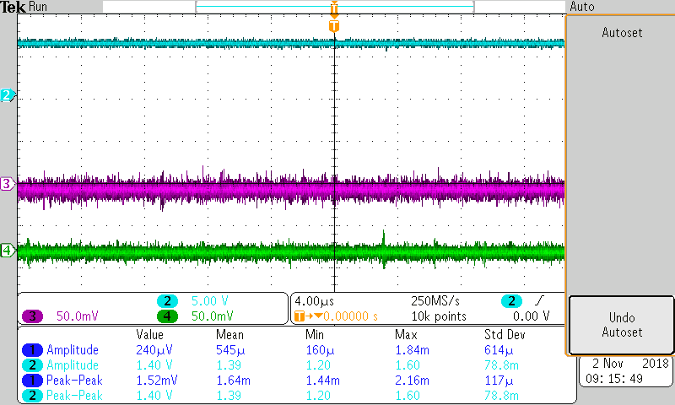

When measured, we can see V2=VGT.

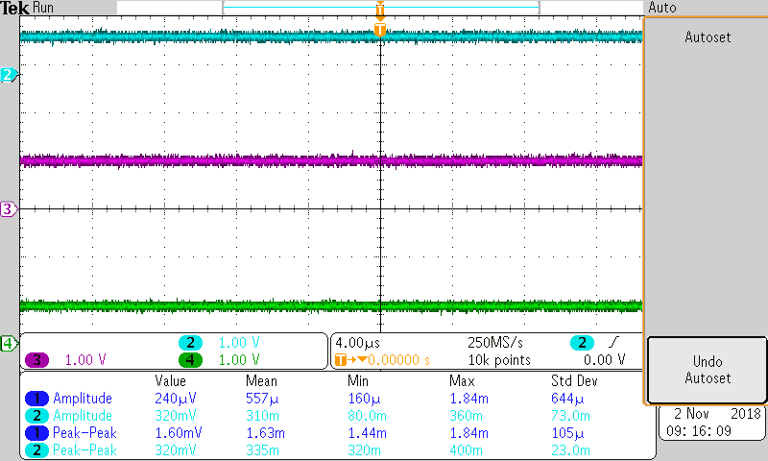

= (2-0.8)/5k

IGT= 240 uA

VGT=V2= 0.8V

**Comparasion:**

Comparing my IGT with the one on the datasheet, we can see it matches almost well.

IGT of datasheet=200uA

IGT calculated=240Ua

And the VGT are close enough

VGT of datasheet=0.7V

VGT calculated=0.8V

**Part Two: Light Dimmer**

In this part of the lab, we are going to build a light dimmer using a thyristor. The circuit should follow the following circuit

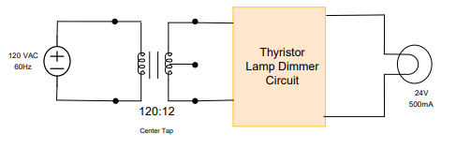

According to my design below, everytime I adjust the 10k resistor, the light bulb dime or get bright.

We can noticed that the change in the resistance across VG change the current IF that make the light to dim or get brighter.

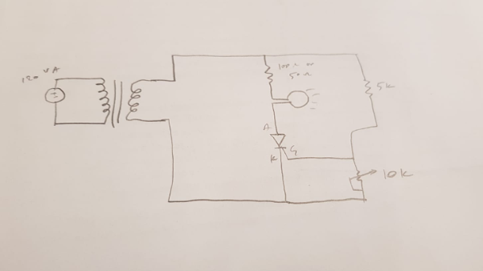

**Part Three: Burglar Alarm**

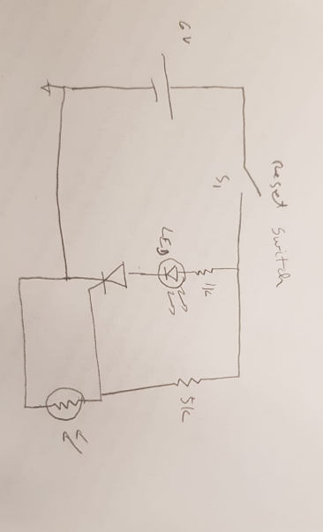

in part 2 of the lab, we notice that while change the resistor 10k between VG, the light deems. For the alarm we can use similar to build the alarm. Since the variation of the 10k potentiometer is affecting the current IF through the lamp, we could put at the place of the potentiometer a photoresistor. Once there is light, the LED will be off. Once the light got cut off, the LED will be turn on.

**Part Four (Extra Credit) : Light Controlled Light Dimmer**

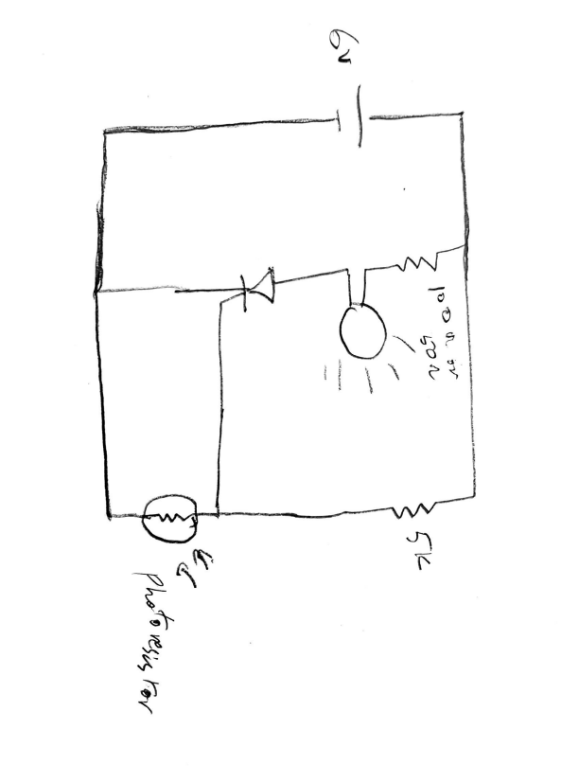

Applying the same principle, we assume that it will work while building a light controlled light Dimmer. However, while we build the circuit in lab the light is not dimming. But while we replace the photoresistor with the 10k potentiometer, we can see the light dimming. That mean the change in resistance at across VG is is changing the current IF. But why with the photoresistor it is not working?

**Conclusion.**

In this lab, we have learned a lot about thyristor and its application. We have measured its key parameters and extracted VGT and IGT. We have also use it to build a light dimer and Burglar alarm. I have also use it to build a light controlled light dimer.